**Computer Graphics**

**BSCS-7A/B**

|  |
| --- |
| **Lab 2: Drawing with points and polylines** |

Objective(s): Upon completion of this lab session, learners will be able to:

|  |
| --- |
| 1. Draw different drawings with points and polylines |

Exercise 1

Write a program to draw following sine Function. Set appropriate gluOrtho2D

1. sin π x/π

x= -4 to 4

1. y=1/2 cos(3x) on domain 0<= x <= 2Π

Exercise 2

Write a program to draw Sierspinki Gaskit using GL_POINTS.

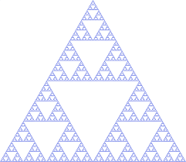

**Steps for drawing**

* Choose three fixed points To, T1,T2 to form some triangle.
* Choose initial point p0 to be drawn by selecting one of the points T0,T1,T2 at random  
  Now iterate the following steps
* Choose one of the three points t0 ti t2 at random call it T.
* Contruct the next point pk as mid point between T and previously found point pk-1 that is pk=midpoint of pk-1 and T
* Pk=midpoint of pk-1 and T
* Draw pk using drawDot()

.

Exercise 3

Write a program to draw dinosaur through file reading.

Dino.txt file is given. Copy it in your project folder

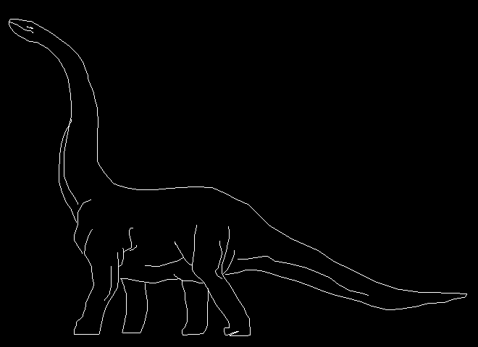

Exercise 4

Write a program to draw flag of Pakistan